VARIABLE POWER SUPPLY 2.6V TO 24V DC 2.5 AMPS USING LM723
22/08/2016 twovolt Leave a comment
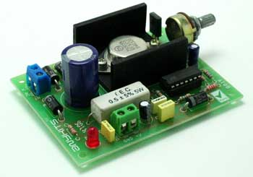
This project provides a variable output power supply ranging from 2.6 to 24 V @ 2.5 A. It’s an ideal add-on to your workbench. Uses the industry populer LM723 in DIP package.
- Supply input 24 VAC
- Output : variable output from 2.6 to 24 V @ 2.5 A regulated low ripple DC voltage
- Heatsink provided for output transistor
- Bridge rectifier made up of discrete 3 A diodes to Convert AC to DC
- LED indication for input
- Screw terminal connector for easy supply input and output connection
- Onboard PCB mounted potentiometer (POT) for varying the output voltage
- Filter capacitors for low ripple DC output
- Four mounting holes of 3.2 mm each
- PCB dimensions 67 mm x 89 mm

