Year | System/ Paper | Scale to 1000s | Primary Index | Secondary Indexes | Transactions | Joins/ Analytics | Integrity Constraints | Views | Language/ Algebra | Data model | my label
1971 | RDBMS | O | ✔ | ✔ | ✔ | ✔ | ✔ | ✔ | ✔ | tables | sql-like
2003 | memcached | ✔ | ✔ | O | O | O | O | O | O | key-val | nosql
2004 | MapReduce | ✔ | O | O | O | ✔ | O | O | O | key-val | batch
2005 | CouchDB | ✔ | ✔ | ✔ | record | MR | O | ✔ | O | document | nosql
2006 | BigTable (Hbase) | ✔ | ✔ | ✔ | record | compat. w/MR | / | O | O | ext. record | nosql
2007 | MongoDB | ✔ | ✔ | ✔ | EC, record | O | O | O | O | document | nosql
2007 | Dynamo | ✔ | ✔ | O | O | O | O | O | O | key-val | nosql
2008 | Pig | ✔ | O | O | O | ✔ | / | O | ✔ | tables | sql-like
2008 | HIVE | ✔ | O | O | O | ✔ | ✔ | O | ✔ | tables | sql-like
2008 | Cassandra | ✔ | ✔ | ✔ | EC, record | O | ✔ | ✔ | O | key-val | nosql
2009 | Voldemort | ✔ | ✔ | O | EC, record | O | O | O | O | key-val | nosql
2009 | Riak | ✔ | ✔ | ✔ | EC, record | MR | O |  |  | key-val | nosql
2010 | Dremel | ✔ | O | O | O | / | ✔ | O | ✔ | tables | sql-like
2011 | Megastore | ✔ | ✔ | ✔ | entity groups | O | / | O | / | tables | nosql
2011 | Tenzing | ✔ | O | O | O | O | ✔ | ✔ | ✔ | tables | sql-like
2011 | Spark/Shark | ✔ | O | O | O | ✔ | ✔ | O | ✔ | tables | sql-like
2012 | Spanner | ✔ | ✔ | ✔ | ✔ | ? | ✔ | ✔ | ✔ | tables | sql-like
2012 | Accumulo | ✔ | ✔ | ✔ | record | compat. w/MR | / | O | O | ext. record | nosql
2013 | Impala | ✔ | O | O | O | ✔ | ✔ | O | ✔ | tables | sql-like
DynamoDB
Key features:
- Service Level Agreement (SLN): at the
- 99th percentile, and not on mean/median/variance (otherwise, one penalizes the heavy users)
- “Respond within 300ms for 99.9% of its requests”
Dynamo (2)
Key features:
- DHT with replication:
  - Store value at k, k+1, …, k+N-1
  - Eventual consistency through vector clocks
- Reconciliation at read time:
  - Writes never fail (“poor customer experience”)
  - Conflict resolution: “last write wins” or application specific
Vector Clocks
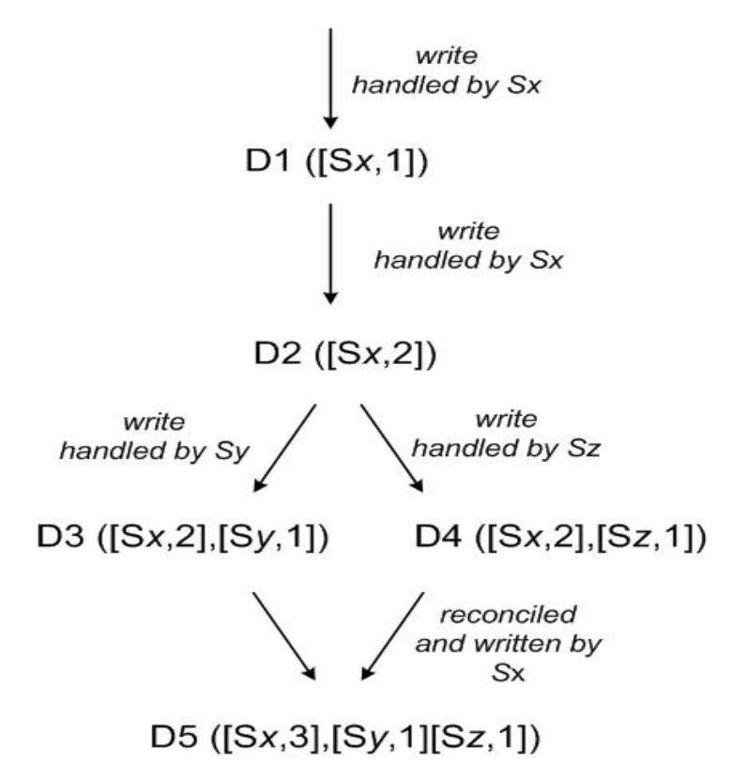
Each data item associated with a list of (server, timestamp) pairs indicating its version history.

Vector Clocks Example
- A client writes D1 at server SX:
D1 ([SX,1])
- Another client reads D1, writes back D2; also handled by SX:
D2 ([SX,2]) (D1 garbage collected)
- Another client reads D2, writes back D3; handled by server SY:
D3 ([SX,2], [SY,1])
- Another client reads D2, writes back D4; handled by server SZ:
D4 ([SX,2], [SZ,1])
- Another client reads D3, D4: CONFLICT !

Data 1 | Data 2 | Conflict?
([SX,3],[SY,6]) | ([SX,3],[SZ,2])
([SX,3]) | ([SX,5])
([SX,3],[SY,6]) | ([SX,3],[SY,6],[SZ,2])
([SX,3],[SY,10]) | ([SX,3],[SY,6],[SZ,2])
([SX,3],[SY,10]) | ([SX,3],[SY,20],[SZ,2])
Configurable Consistency
- R = Minumum number of nodes that participate in a successful read
- W = Minumum number of nodes that participate in a successful write
- N = Replication factor
- If R + W > N, you can claim consistency
- But R + W < N means lower latency.

