Ok, I just checked the database, wasn't able to download code. I would prefer FTP access instead of SSH.

Anyway, the important thing here is the database. Let me give you my opinion on it.

Short explanation (don't get offended): one of worst I have ever seen. It is completelly useless, with no rules and no consistency.

Longer explanation:

Problem 1:
all tables are Myisam! Myisam doesn't support foreign-keys and is NOT acid compliant. It means that it is very, very easy to loose data on loaded servers, you will get so-called garbage, speed is slower then InnoDB and whole lot more problems.

Problem 2:
When you don't have foreign-keys and you have relation (for example) Category has many Images, when you delete Category, you must also write a code that will delete related images too. In big programs, with lot of relations, this is slow, it is big waste of time and is very easy to forget some relation. With foreign-keys, you only do $acategory->delete() and all related objects are deleted too. In this case, my program also takes care of deleting file and thumbnail too (application level delete in Doctrine, just 1 line of code).
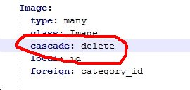

Problem 3:
tables have inconsistent collation; check this image, you will see that some tables are utf-general-ci, some are latin1-sweedish... I have see a lot of bad databases, but never an idea like this.

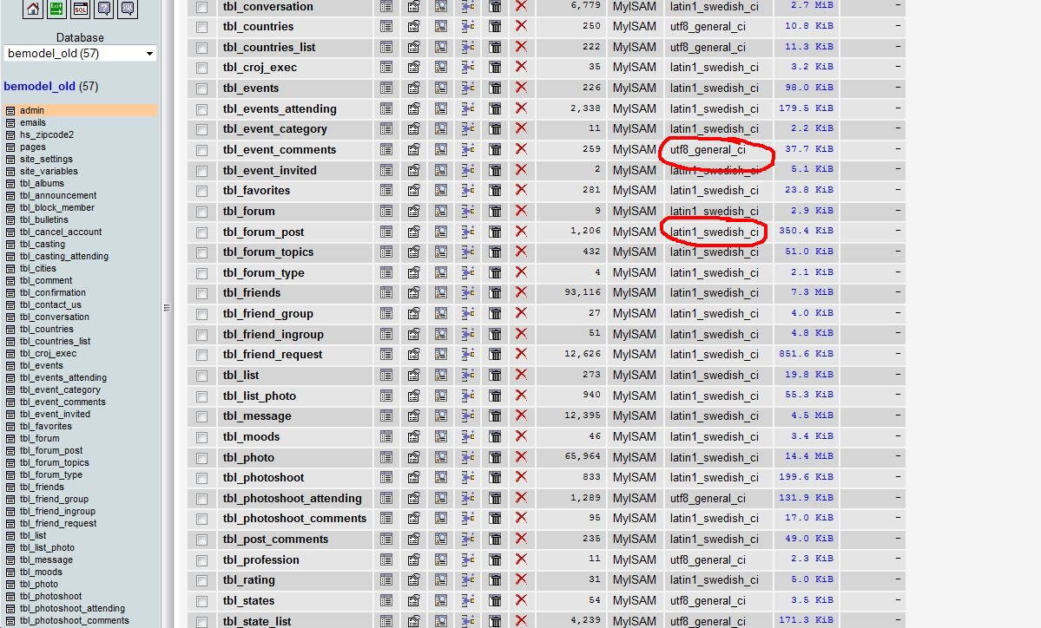
You will have a lot of problems with this; when german and spanish letters are used, you will never have them displayed correctly because of that.

Problem 4:
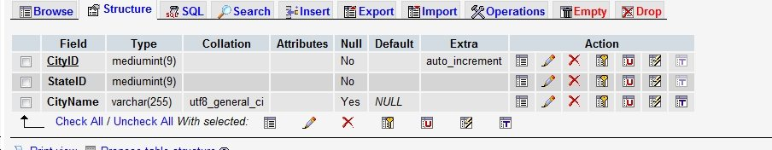
Another inconsistency; check column names here:

and here:
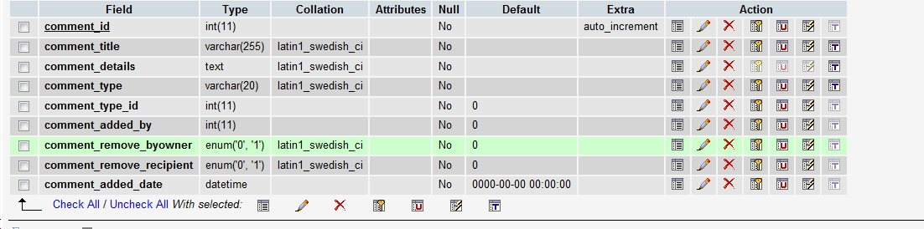
Not only the problem is having different naming conventions, but also the idea of using table's name as prefix in columns. Why would you put column „comment_id“ in table „comment“? When you name column like „tablename_id“, every single php tutorial will tell you it is related to table „tablename“ and its „id“.

I hope you understood me.

Problem 5:
This one is insane, table tbl_user:
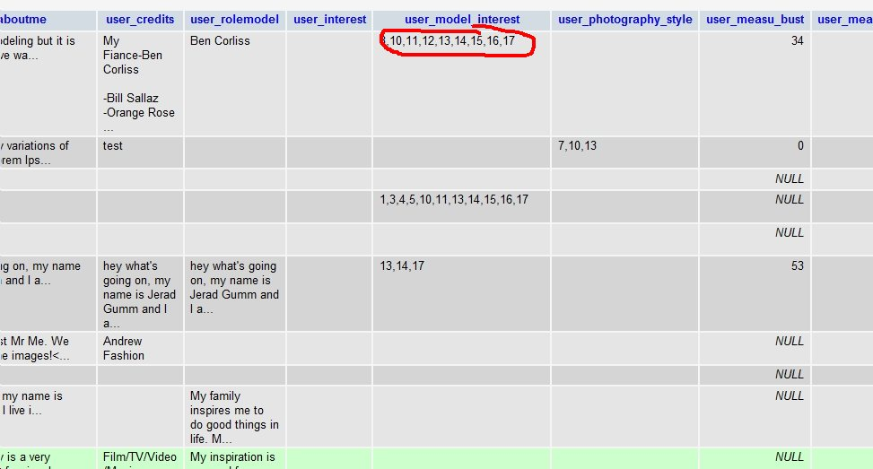
So instead of creating real many-2-many relational table, he saves id's separated by commas? But other tables like tbl_event_category are many-2-many as it should be done (but alas, no FK's).

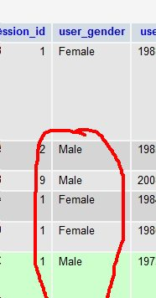
Another bad idea; using text to indicate „male“ or „female“. Why would anyone use text instead of int(1)? 0 for men, 1 for women and that's it!

This is not the only table that has this idea, but I hope you see the point (I don't know what is your DB knowledge).

Problem 6:
There are tables „tbl_countries“ and „tbl_countries_list“. I have no idea why there are 2 tables doing the same thing.

Problem 7, table „user_employed“:
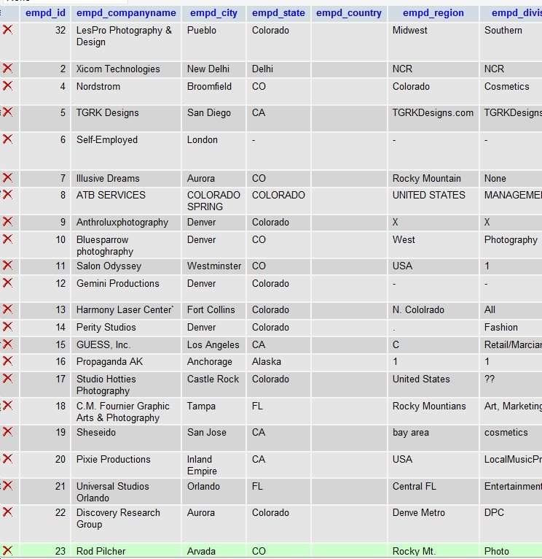

There are tables for cities, states and countries, yet, this guy not only duplicated all 3 instead of just having „city_id“ but duplicates it as TEXT, not by id!

Problem 8:
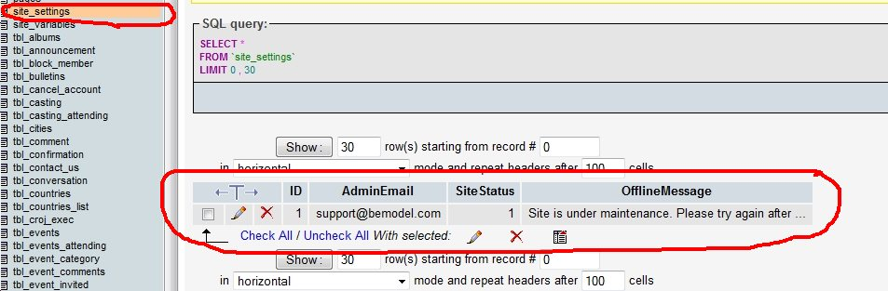
Obviosly, program doesn't let you to have many settings:
Having settings in DB is bad, bad idea. How would you add new options? By expanding table in width?

Check my settings:

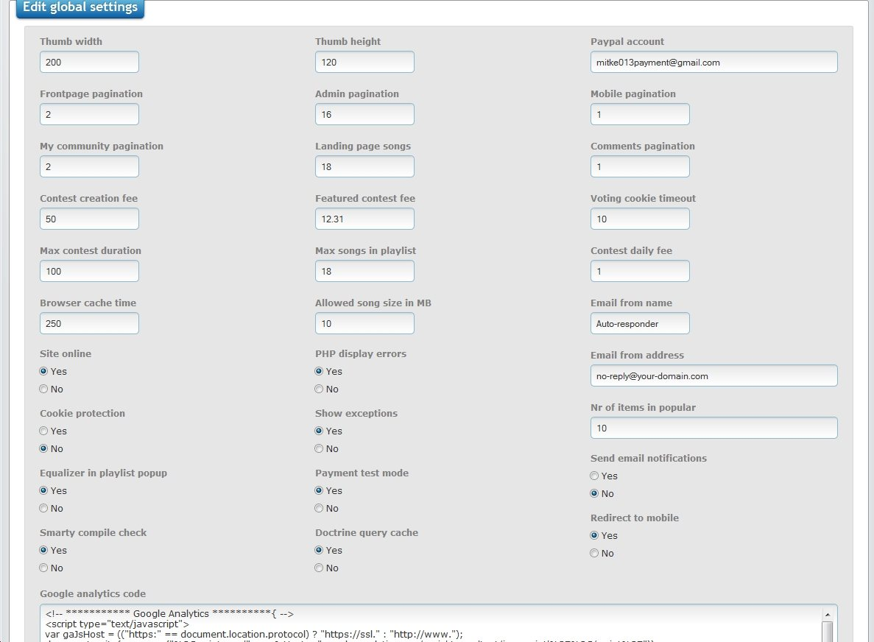
(Not all options was able to stand in browser when I created this screenshot)

I use .ini file which saves data in key=>value combination, it is very fast and adding new option is ~1 minute; 2 lines in Settings class (validation rules etc) and the <label> and <input> element in form. Yes, that is all!
And using it is this php code:
$pagination = Settings::getInstance()->getAdminPagination() ;

Nothing beyond this, you can add as many options as you want for any part of program. In above image, you can even see an option for both admin and frontpage pagination, but also that „my community“ page and nr of comments per-page has separate options for pagination.

The point:
I can go on and on and on... but you can see in which way it would go anyway. And this review is just 5 mins of me analyzing the database, most of the time randomly selecting the table.

In short:
your database is completelly useless. If you plan to keep it, sorry, I am not interested. I don't want fingers pointed to me once the problems become to appear. And they will, there is no doubt in it.

I can see the code, but it is pointless. When someone creates DB that bad, php code is for sure even worse. It is obvious that this DB was created by different people so probably the code is also done that way.

My proposal:
Complete rewrite. Yes, I am aware that you already payed this program, but you were tricked and life goes on. I am not going to teach you how to deal business, but I wouldn't test my luck again if I were you. And no; I am not telling I am the best, there are lot of good programmers around, it is only the point if you want code fixed, instead of rewritten, you will have problems more and more... till you finally decide rewrite is the only possible solution. Sorry, but it is reality, I have seen things like this before in almost 95% cases. I can prove that, still have some of programs like this that I had to rewrite (xxx as one of them, I sent you link before).

