30th July 2012, 08:36 PM | #774
Junie  diyAudio Member  Join Date: Sep 2010  Location: Dubai, UAE | Hello Amptech,  In the final PCB Alex include it (enclosed in red), please see below photo.  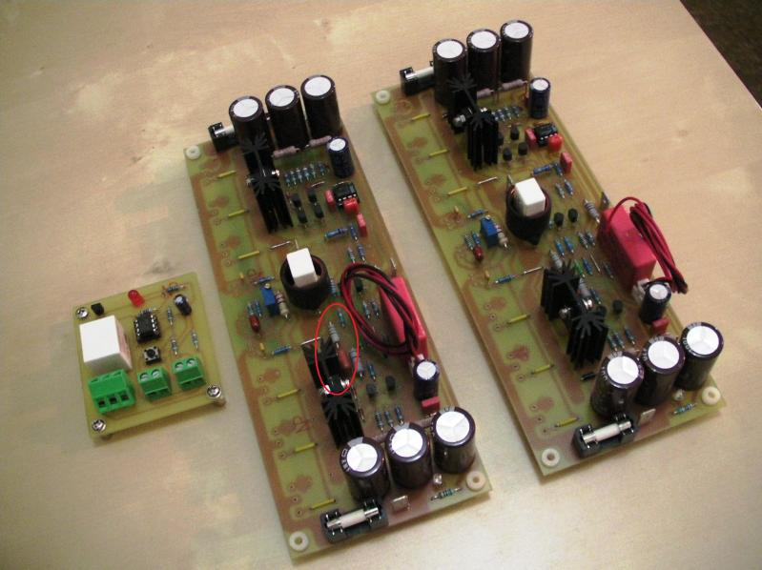.  Actually my approach on finding the fault is from OP backward but I noticed that whenever I touch components in the input stage the buzzing sound is there and the Light bulb is glowing happily, double checked the schematic and found the cap(100pF) is missing.  Cheers,  Junie
30th July 2012, 08:40 PM |  | #775
Junie  diyAudio Member  Join Date: Sep 2010  Location: Dubai, UAE |  | I'm actually planning to move Zobel network to Speaker terminal.

30th July 2012, 09:43 PM |  | #776
wiljj78  diyAudio Member  Join Date: Mar 2012  Location: Bahrain |  | Quote:  Originally Posted by Junie  Ok here's what i found, in the schematic below the 100pF(enclosed in red) is not included in Alex's PCB version 3.1.  With the inclusion in my build it removes that unwanted oscillation, noticed how did i solder in the back of the PCB.  Congrats....and thanks for sharing.  Which version is working fine??  Regards,
1st August 2012, 07:41 AM | #777
apexaudio  diyAudio Member  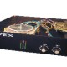  Join Date: Feb 2010  Location: Serbia | :  Quote:  Originally Posted by Junie  Ok here's what i found, in the schematic below the 100pF(enclosed in red) is not included in Alex's PCB version 3.1.  With the inclusion in my build it removes that unwanted oscillation, noticed how did i solder in the back of the PCB.  __________________  http://www.facebook.com/APEXaudio.MileSlakovic

2nd August 2012, 08:52 PM | #778
dobrivoje  diyAudio Member  Join Date: Aug 2009  Location: Smederevo, Serbia | Alex MM left free space for missing cap. Just add red pads and small red connection.  Attached Thumbnails

