2X22W/12V STEREO AMPLIFIER

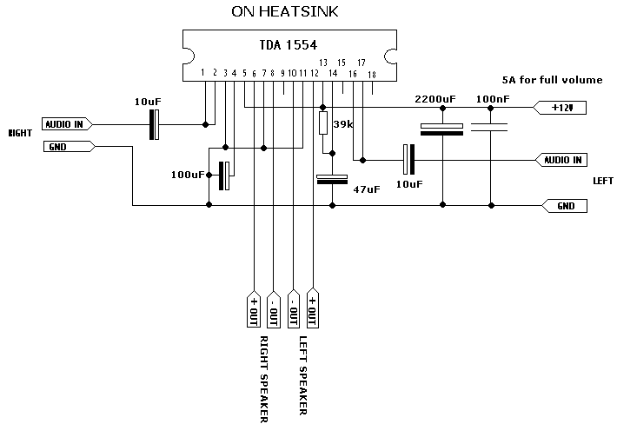

The 22 watt amp is easy to build, and very inexpensive. The circuit can be used as a booster in a car audio system, an amp for satellite speakers in a surround sound or home theater system, or as an amp for computer speakers. The circuit is quite compact and uses only about 60 watts.
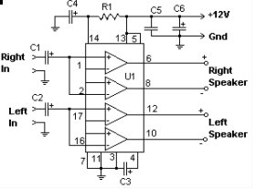
R1 | 39kΩ
C1, C2 | 10 µF
C3 | 100 µF
C4 | 47 µF
C5 | 0,1 µF
C6 | 2200 µF
U1 | TDA1554
Ω

1. The circuit works best with 4 ohm speakers, but 8 ohm units will do.
2. The circuit dissipates roughly 28 watts of heat, so a good heatsink is necessary. The chip should run cool enough to touch with the proper heatsink installed.
3. The circuit operates at 12 Volts at about 5 Amps at full volume. Lower volumes use less current, and therefore produce less heat.
4. Printed circuit board is preferred, but universal solder or perf board will do. Keep lead length short.
